Beer Name: Sweetgrass Ale
Brew Date: June 2’20
Batch Size: 10 gal
Target OG/◦P: 1.039
Amnt lb/kg Ingredient
10 # munich
5 # wheat
1 # cara-pils
1 # vienna

Qt oz/g Hop/Seasoning Time:
32 g cascade 60 min
28 g hallertauer 20 min
14g hallertauer dry hop
56 g sweetgrass 1 min

Stage Date
Primary:
Racked:
Bottled:
Kegged:
Re-Kegged:
Purged: Charged:

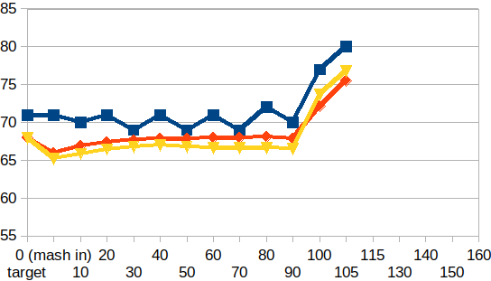
Start Time: 6:45
Fill mash tun:
Fill sparge kettle:
Fire burners:6:45 am
Heat Mash Tun : Target Temp: 66-68
Heat Sparge Kettle: Target Temp: 75
Target Temp (Mash): 66-68
Grind grain: 7:15 am
Strike Temp: 68.1
Mash in: 7:45am
Temp: 65.9
Mash: Duration: 90 minutes
Start: 7:45 Finish: 9:15
Heat (to deactivate enzymes)
Target Temp: 75.5
Start: 9:15 Finish: 9:30
Heat Sparge H20 (Target175◦)
Sparge: Start: 9:53 Finish:10:25
Wort collected: less than full kettle to try out Fermenator
Boil : Burner On: 9:55
Rolling Boil: 10:40
Hops In: 11:10 Hops In: 11:50 Whirflock in: 11:55 Sweetgrass in: 12:09pm
Duration: 90 min Start: 10:40 Finish: 12:10pm
Burner Off: 12:10
Rest 15 min
Pump and chill: Start: 12:25 Finish:
OG : 1.044
Yeast: Safbrew s-33
Irish Moss 2x
Notes: Rack onto hops in secondary

